***MOVIE REVIEW WEBSITE***

***OUTPUT***

1. ***Home Page –*** Browse through a curated list of popular movies.The layout is built using **flexbox**, ensuring responsive design across devices​

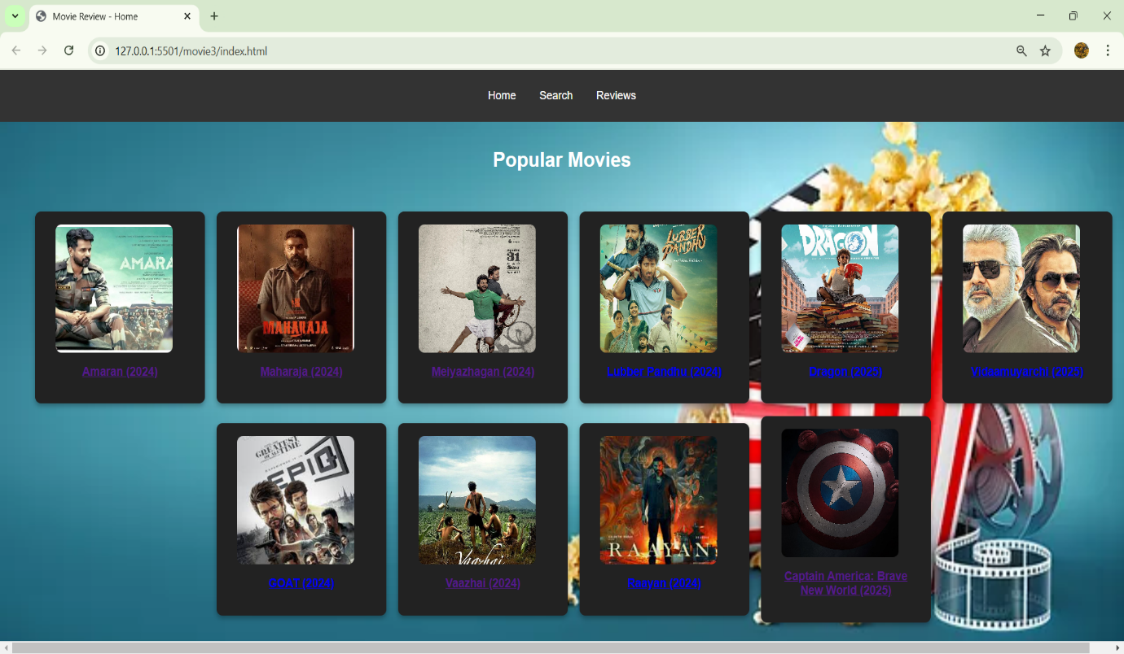

2) ***Movie Details Link*** – Click to explore in-depth information about the movie.

The hover effect on movie posters uses **CSS transitions** to create smooth interactions

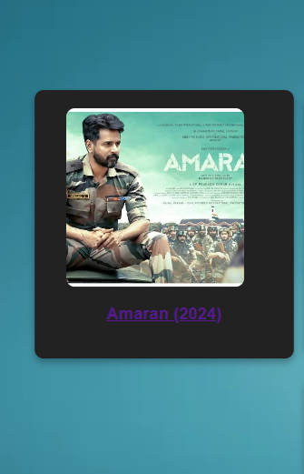

3) ***Movie Details Page*** – View complete movie details. The layout is styled using **flexbox** for proper content alignment​.

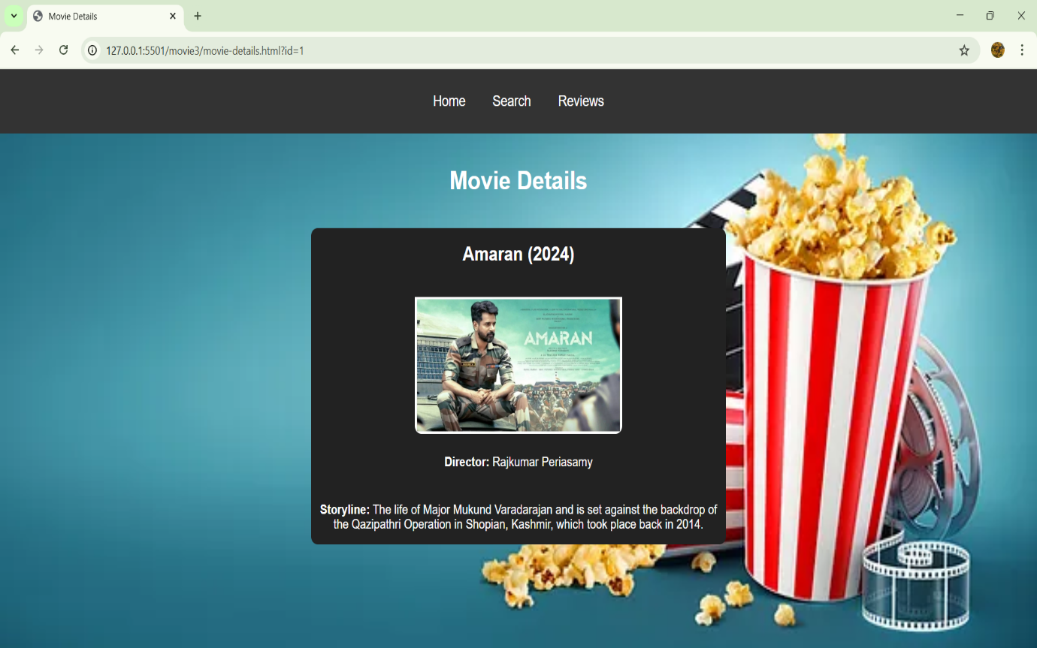

4)***Search Feature*** –Instantly find movies with an intuitive **dropdown search.**The dropdowns are styled with custom borders and padding for better usability​.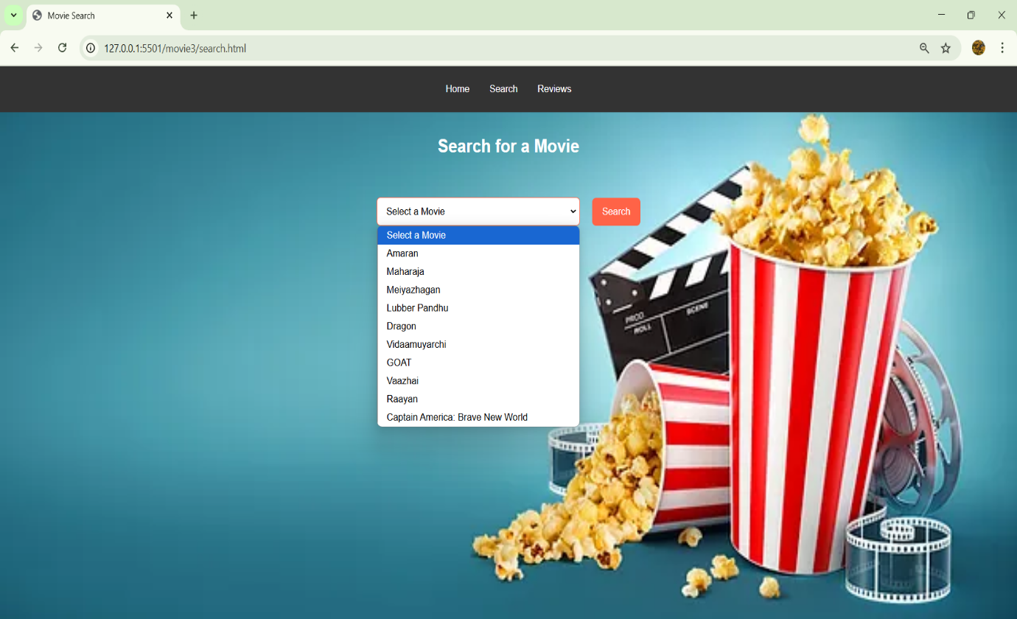5) ***Movie Reviews Section***– Read user-generated reviews and insights with movie description.

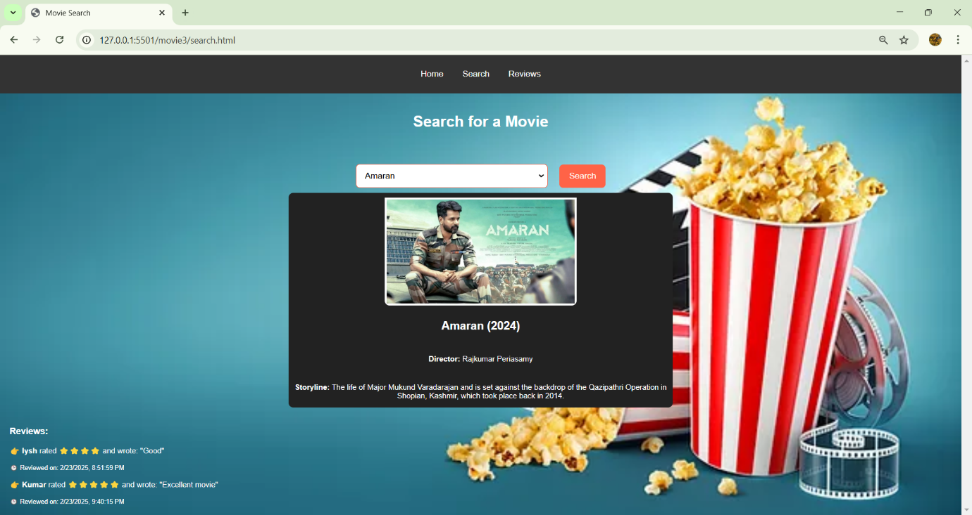

6) ***Post a Review*** – Share your thoughts on the movie by submitting a review. Submit a movie review with an enhanced **star rating system**

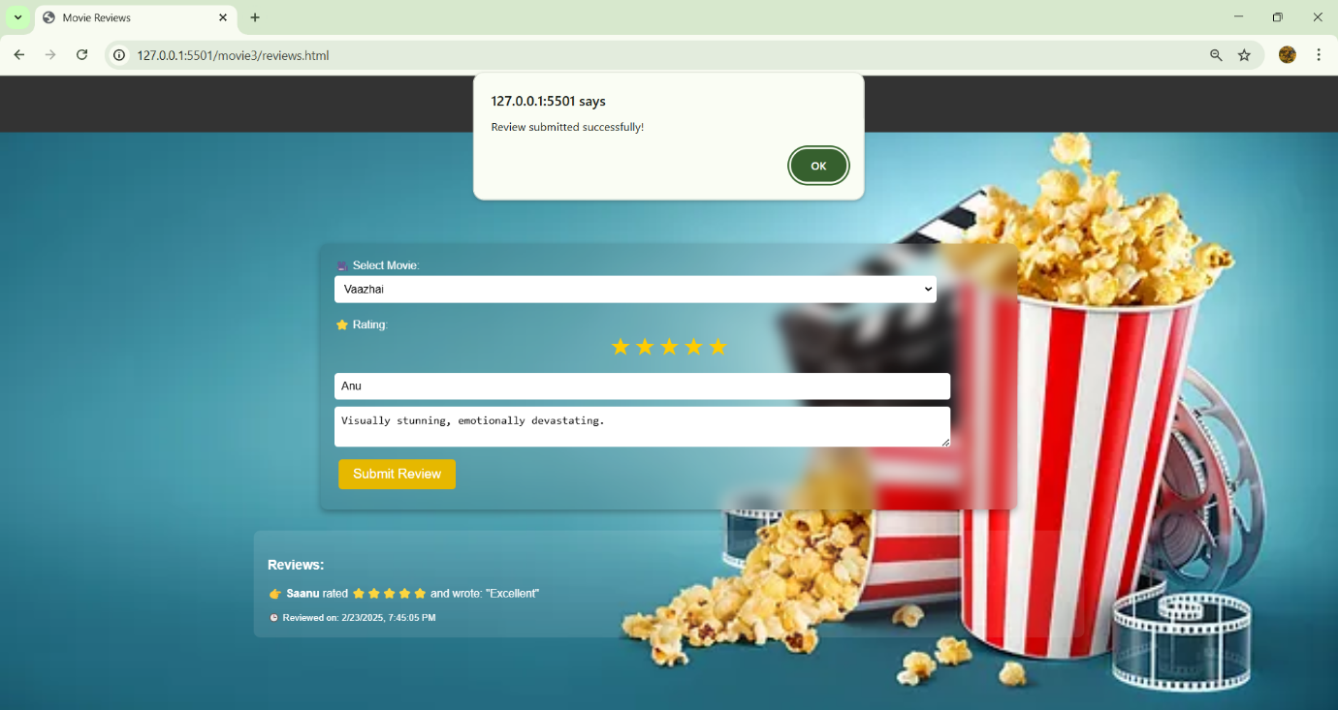

7) ***All Reviews Display*** – View all posted reviews in a structured format with **drop-shadow effects**, improving readability and visual appeal​

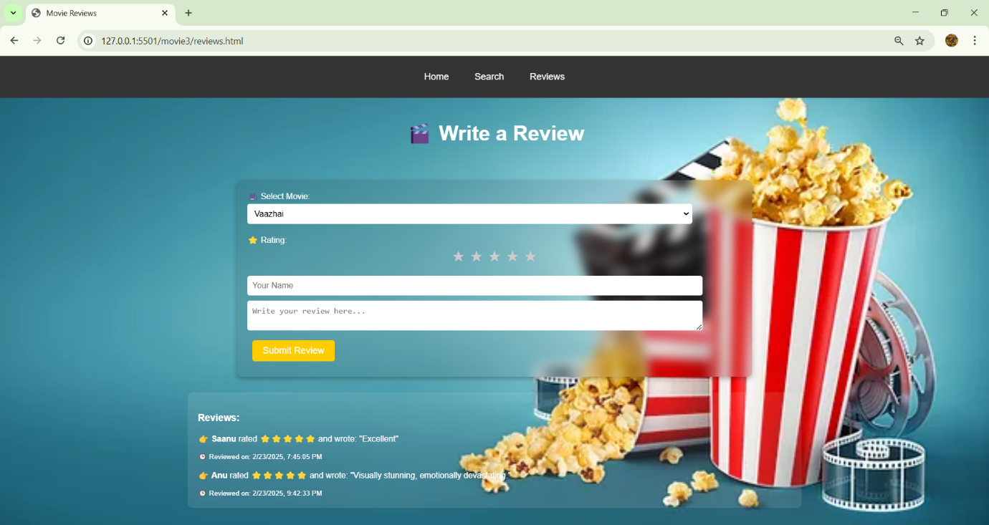

8)***Review on Search Page*** – See newly added reviews reflected in the search results.

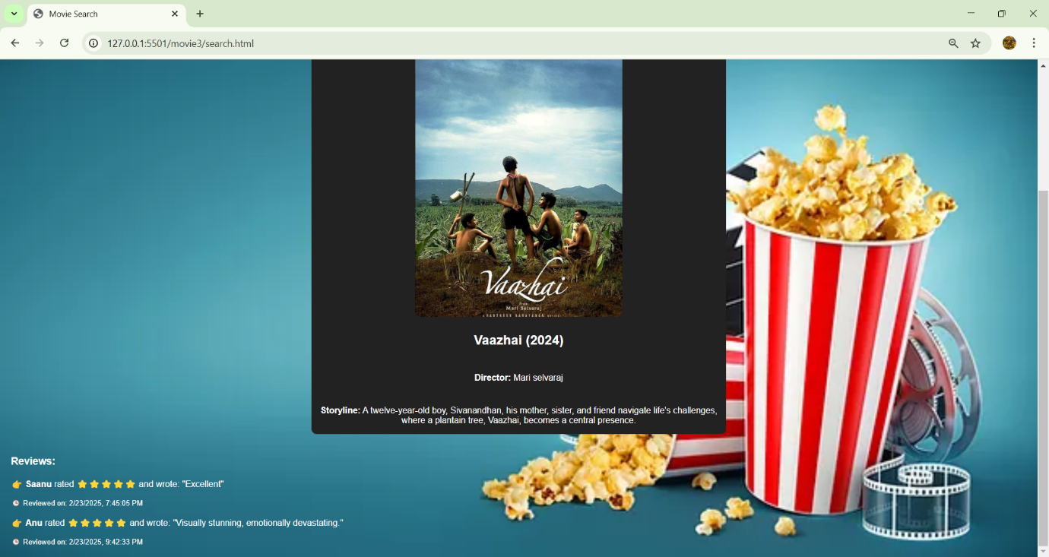

***Mobile View*** – A seamless and responsive experience on mobile devices.

